Report
Team ID | MCA
Project Name | Smartphone Usage, Digital Addiction & Well-Being Analytics
Maximum Marks | 5 Marks
A report is a structured document that presents the analysis, findings, and insights obtained from a dataset. In this project, Power BI is used to analyze smartphone usage, digital addiction, screen time, social media activity, gaming, stress levels, sleep patterns, and work/study behavior. The report combines KPI cards, bar charts, donut charts, line charts, interactive filters, and Key Influencers to provide a clear understanding of digital behavior and well-being.
The Power BI report is designed with a consistent layout and visual theme so that important information can be understood quickly. Filters such as age group, gender, addiction level, and stress level allow users to interact with the report and examine specific segments of the data. The combination of summary measures and detailed visualizations makes the report useful for identifying patterns and relationships in smartphone usage.
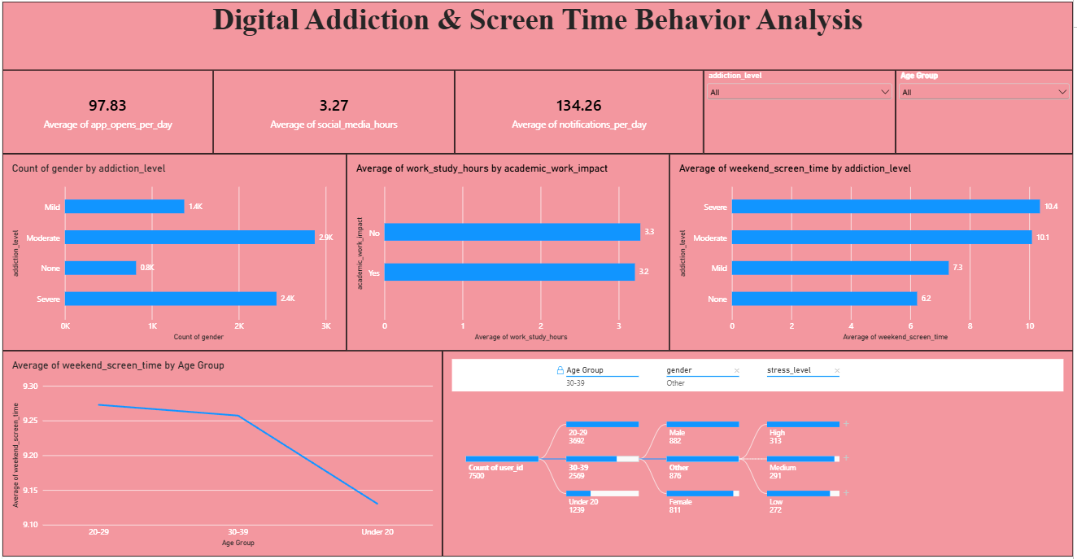
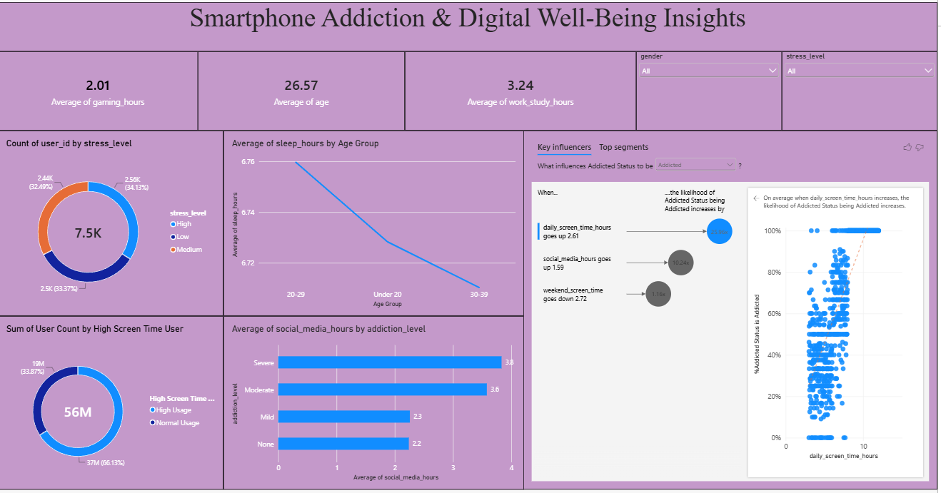
Observations drawn from the Power BI report
Observations from the Power BI reports provide valuable insights into smartphone usage patterns, digital addiction and well-being.
1. Smartphone Usage Analysis
- The dashboard shows an average of 97.83 apps opened per day, indicating frequent smartphone interaction among the users.
- Users receive an average of 134.26 notifications per day, showing a high level of digital activity and interaction with smartphone applications.
- The average social media usage is 3.27 hours per day, while the average gaming time is 2.01 hours per day.
2. Digital Addiction Level Analysis
- The addiction-level chart shows approximately 2.9K users in the Moderate category, followed by 2.4K Severe, 1.4K Mild, and 0.8K None.
- Average weekend screen time increases across the addiction categories: 6.2 hours for None, 7.3 hours for Mild, 10.1 hours for Moderate, and 10.4 hours for Severe.
- The visual therefore highlights substantial differences in weekend screen-time averages across the addiction categories.
3. Age Group and Screen-Time Analysis
- The average age of users in the dataset is 26.57 years.
- The average weekend screen-time chart shows differences among age groups, with the 20–29 group at approximately 9.27 hours, the 30–39 group at about 9.26 hours, and Under 20 at about 9.13 hours.
- This comparison helps identify variations in weekend smartphone usage among different age groups.
4. Stress and Level Analysis
- The stress-level distribution contains approximately 2.56K High-stress users (34.13%), 2.50K Medium-stress users (33.37%), and 2.44K Low-stress users (32.49%).
- Average sleep hours are approximately 6.76 hours for the 20–29 group, 6.73 hours for Under 20, and 6.71 hours for the 30–39 group.
- These visuals provide a comparison of sleep patterns and stress levels across the user population.
5. Social Media Usage by Addiction Level
- Average social media usage increases across addiction levels, with approximately 2.2 hours for None, 2.3 hours for Mild, 3.6 hours for Moderate, and 3.8 hours for Severe users.
- The Key Influencers visual identifies higher daily screen time, social media usage, and weekend screen time as factors associated with the Addicted status in the dataset.
- In the displayed analysis, daily screen time above 2.61 hours is associated with a 25.6× increase in the likelihood of the displayed outcome, while social media usage above 1.59 hours is associated with 10.24×. These figures represent the Power BI Key Influencers analysis for this dataset.
6. Work/Study and Digital Well-Being
- The average work/study time is 3.24 hours, while the average age is 26.57 years.
- The work/study-hours visual shows average values of approximately 3.3 hours for users without the displayed academic-work impact and 3.2 hours for users with it.
- Overall, the two Power BI pages provide a consolidated view of screen time, addiction, social media, gaming, stress, sleep, and work/study behavior, making it easier to explore patterns in smartphone usage and digital well-being.

